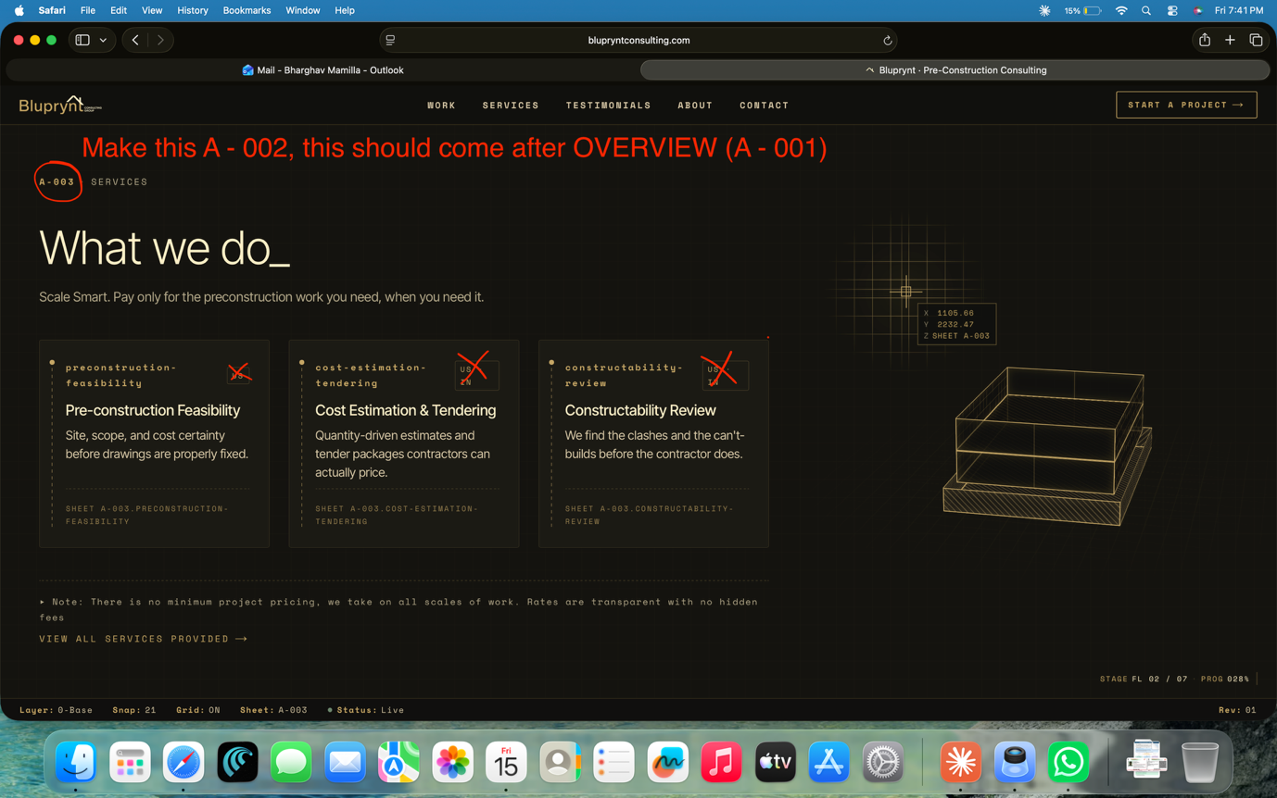
Card 1
- Slug: concrete-takeoff-estimation
- Title: Concrete Takeoff & Estimation
- Body: Detailed concrete quantity takeoffs with marked-up drawings and bid-ready cost estimates. Submitted in your format, on your bid clock.
- Rate: FROM $40 / HOUR
Card 2
- Slug: rebar-shop-drawings
- Title: Rebar Shop Drawings
- Body: Fabrication-ready rebar shop drawings and bar lists. Detailing by engineers who've worked alongside US fabricators.
- Rate: FROM $24 / TON
Card 3
- Slug: slab-edge-drawings
- Title: Slab Edge & Dimensional Drawings
- Body: Slab edge layouts and dimensional control drawings, sheet-by-sheet, coordinated against the structural and architectural sets.
- Rate: FROM $200 / SHEET
Card 4
- Slug: soe-takeoffs
- Title: Support of Excavation Takeoffs
- Body: SOE quantities for tieback, soldier-pile, and lagging systems — sequencing and a defensible cost basis the estimator can hand straight to the bid.
- Rate: (BY SCOPE)
Card 5
- Slug: submittal-coordination
- Title: Submittal Coordination
- Body: End-to-end submittal log management — RFI tracking, approval routing, document control — so your PM stops chasing emails.
- Rate: FROM $2,500 / MONTH

Layout:
5-card vertical stack on mobile,
3+2 on desktop. 3 + 2 grid (cleanest, recommended) — top row Concrete / Rebar / Slab Edge, bottom row SOE / Submittal Coordination.

